

**COS20001: User-Centered Design**

6.2) Evidence of Iterative Design

**Group 4**

**Introduction**

Prototype evaluation and testing play a vital role in the demonstration of software’s features, not only to the users but also to the members of the developing team as well as managers at an executive level. Prototype iteration, therefore, is a crucial step in any software’s life cycle. It is important for Information Technology students to critique, review, test ,and redesign user interface design. In this document, we will look at multiple constructive feedbacks and recommendations that were given to our team by the lecturer as well as other teams.

**A. Advantages**

**1. Clear and minimalistic design**

Our design is appreciated for its minimalistic and clear design, with the use of vibrant color palette and familiar visual elements, it would be extremely easy for new users to get used to our platform, therefore, reduce the entry barriers and improve users’ usability.

Based on the constructive feedbacks of our lecturer and evaluator, we have been trying to improve our design to gain a competitive advantage against our competitor.

Figure 1.1. Homepage

Figure 1.2. Log In

**2. Appropriate match between system and the real world**

Our prototype’s language and flow of work, after various evaluating round and feedbacks, are said to be easy to follow. The barrier of entry is minimal but at the same time it still provides sufficient functionalities for the software. The presentation of elements is also artistic and modern.

Figure 2.1. Settings section, with the Language option being the second option

Figure 2.2. Language section

**3. Recognition rather than recall**

With the use of clearly visible and familiar object, the users do not need to remember exactly every information the software has to offer.

Figure 3.1. Log in page with many familiar elements such as Username or Password

**B. Disadvantages**

Apart from the advantages and marvelous compliments above, there are still rooms for improvement to help our team to tailor our design and create a better version of our product. The noteworthy imperfection in the design are as follows:

**Problem #: 1**

**Evaluator feedbacks:** “I cannot type in my information in the log in and registration box.”

**Evaluator information:**

|  |  |  |  |
| --- | --- | --- | --- |
| **Timestamp** | **Email address** | **Occupation** | **Link to agreement** |
| 7/18/2022 15:39:52 | lehuutuong03@gmail.com | College student | [Link](https://docs.google.com/spreadsheets/d/1ryRPkpEnfVK5eqHzG9V1Z_vUIKZQJlFm/edit#gid=993369257) |

**Prototype screen, page, location of problem:** Login page and Registration page.

Figure 4.1. Log in Page

Figure 4.2. Sign Up page

**Name of heuristic:** Error prevention.

**Reason for reporting as negative or positive:** The log in page does not allow participants to type in their information.

**Scope of problem:** Log in and registration page.

**Severity of problem (scale 0-4):** 4: Usability Catastrophe

* **Frequency (common – rare):** Common.
* **Impact (easy – difficult to overcome):** Difficult to overcome.
* **Persistence (one-time – ongoing problem):** Ongoing problem.

**Justification for severity rating:** Although this is just a prototype, the testing process with our evaluators was severely affected as they were not able to type in the information both in log in and in registration pages. The evaluators were, consequently, had to use a provided account to continue the evaluation process.

**Suggestions to fix:** Add a text field for the users to provide their information.

**Solution from our team:** The feedbacks provided by evaluator were as critical as it is helpful for our team, after receiving the information, we have immediately added a text box to the log in page and registration page so that other evaluators can provide their information.

**Before and after screenshots:**

Figure 4.3.1. Login before input.

Figure 4.3.2. Login after input.

Figure 4.4.1. Sign Up before input.

Figure 4.4.2 Sign Up after input

**Problem #: 2**

**Evaluator feedbacks:** “I cannot log in via Facebook or Gmail.”

**Evaluator information:**

|  |  |  |  |
| --- | --- | --- | --- |
| **Timestamp** | **Email address** | **Occupation** | **Link to agreement** |
| 7/18/2022 15:37:49 | khanhqnvsws00068@fpt.edu.vn | College student | [Link](https://docs.google.com/spreadsheets/d/1ryRPkpEnfVK5eqHzG9V1Z_vUIKZQJlFm/edit#gid=993369257) |

**Prototype screen, page, location of problem:** Log in page.

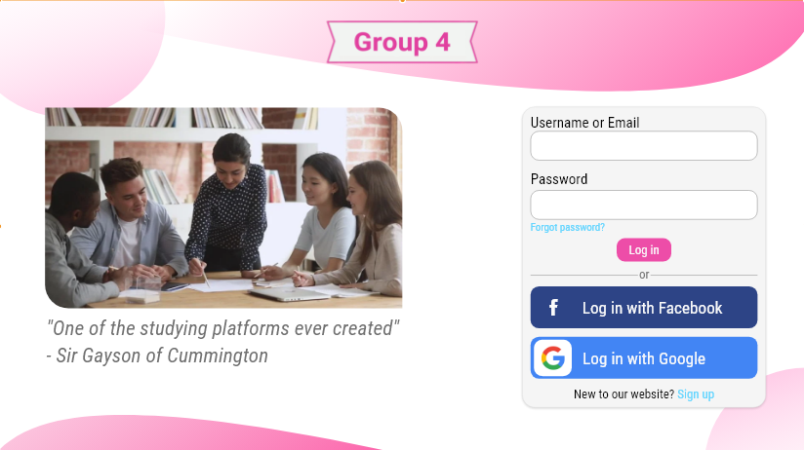

Figure 5.1. The “Log in with Facebook” and “Log in with Google” did not have any follow-up page

**Name of heuristic:** Consistency and standards

**Reason for reporting as negative or positive:** The log in page does not allow participants to sign in using Facebook account or Gmail account.

**Scope of problem:** Log in page.

**Severity of problem (scale 0-4):** 2: Minor problem.

* **Frequency (common – rare):** Rare.
* **Impact (easy – difficult to overcome):** Easy to overcome.
* **Persistence (one-time – ongoing problem):** one-time problem.

**Justification for severity rating:** There are buttons to provide users with the ability to sign into the platform via Facebook and Google; however, the buttons do not seem to work.

**Suggestions to fix:** Fix the function of the button.

**Solution from our team:** The feedback from the evaluators is extremely helpful to help our team to recognize the flaws in our system, after receiving this feedback, we immediately fix the buttons so that it would work normally.

**Before and after screenshots:**

Figure 5.2. Logging in with Facebook, a page previously not present

Figure 5.3. Logging in with Google

**Problem #: 3**

**Evaluator feedbacks:** “Some buttons do not work or malfunction, the back button and the publish button on the quiz creation page for example.”

**Evaluator information:**

|  |  |  |  |
| --- | --- | --- | --- |
| **Timestamp** | **Email address** | **Occupation** | **Link to agreement** |
| 7/18/2022 15:40:38 | khanhqnvsws00068@fpt.edu.vn | College student | [Link](https://docs.google.com/spreadsheets/d/1ryRPkpEnfVK5eqHzG9V1Z_vUIKZQJlFm/edit#gid=993369257) |

**Prototype screen, page, location of problem:** Quiz page.

Figure 5. The Quiz Creation page’s Back button did not function properly.

**Name of heuristic:** Consistency and standards

**Reason for reporting as negative or positive:** Some buttons do not work and some of them malfunction.

**Scope of problem:** Quiz page and quiz creation page.

**Severity of problem (scale 0-4):** 2: Minor problem.

* **Frequency (common – rare):** Common.
* **Impact (easy – difficult to overcome):** Easy to overcome.
* **Persistence (one-time – ongoing problem):** one-time problem.

**Justification for severity rating:** Some buttons, for example, the “back” button malfunctions and does not lead the users to their desired page. There are also a handful of buttons that do not work.

**Suggestions to fix:** Fix the function of the button or add function to the button that does not work.

**Solution from our team:** The feedback from the evaluators is extremely helpful to help our team to recognize the flaws in our system, after receiving this feedback, we immediately fix the buttons so that it would work normally.

**Before and after screenshots:**

Figure 6.2. The button “Back” not linking to Homepage

Figure 6.3. The button “Back” linked to Homepage

**Problem #: 4**

**Evaluator feedbacks:** “The theme changing function does not work.”

**Evaluator information:**

|  |  |  |  |
| --- | --- | --- | --- |
| **Timestamp** | **Email address** | **Occupation** | **Link to agreement** |
| 7/18/2022 15:43:55 | phamvunguyennhi@gmail.com | College student | [Link](https://docs.google.com/spreadsheets/d/1ryRPkpEnfVK5eqHzG9V1Z_vUIKZQJlFm/edit#gid=993369257) |

**Prototype screen, page, location of problem:** Profile page.

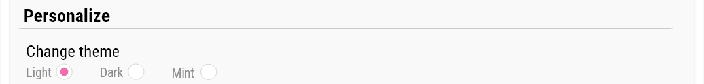

Figure 7.1. Themes option

Figure 7.2. The default theme, while the settings had a themes option it was not functional.

**Name of heuristic:** Consistency and standards

**Reason for reporting as negative or positive:** The theme changing function on profile page does not work.

**Severity of problem (scale 0-4):** 2: Minor problem.

* **Frequency (common – rare):** Common.
* **Impact (easy – difficult to overcome):** Easy to overcome.
* **Persistence (one-time – ongoing problem):** one-time problem.

**Justification for severity rating:** Our time primary and utmost objective in this project is to improve users’ customization and personalization ,and theme changing is one of the most important functions. Therefore, the fact that the theme was not able to change is a serious matter.

**Suggestions to fix:** Fix the function of the button or add function to the button that does not work.

**Solution from our team:** The feedback from the evaluators is extremely helpful to help our team to recognize the flaws in our system, after receiving this feedback, we immediately fix the theme changing function so that it would work normally.

**Before and after screenshots:**

Figure 7.3.1. Dark theme selected

Figure 7.3.2. Dark theme active

Figure 7.4.1. Mint theme selected

Figure 7.4.2. Mint theme active